**Production and Machine Analysis**

TABLES:-

Machine Data Table: -

* **Machine ID**
* **Maximum Capacity**
* **Installation Date**
* **Asset Description**
* **Serial NO**
* **Assembly Name**

Failure Machine Data Table: -

* **Failure Date**
* **Shift**
* **Shift In charge**
* **Machine ID**
* **Expected Output**
* **Total Output**
* **Downtime (Hrs)**
* **Defect Count**
* **Defect Reason**
* **Work Order ID**
* **Repair Start Date**
* **Repair End Date**
* **Resolution Reason**
* **Repair Hours**

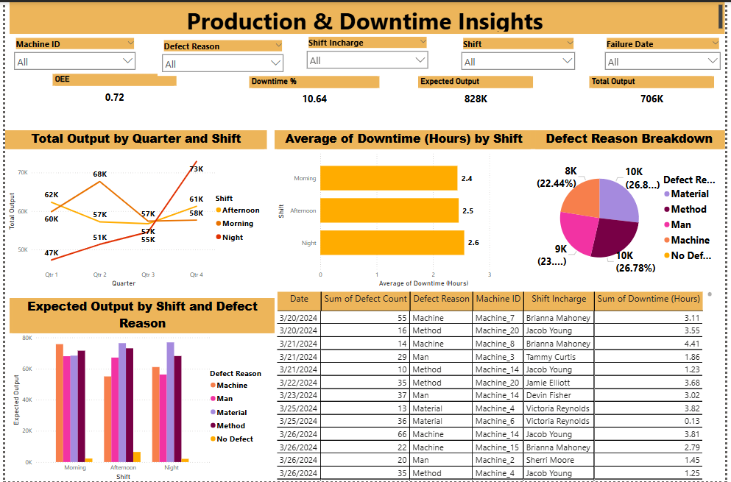

## **Key Insights from the Report**

### **1️⃣ Overall Equipment Effectiveness (OEE) & Downtime%**

* **OEE (0.72 or 72%)** → Measures how effectively machines are utilized.
* **Downtime % (10.64%)** → Indicates the percentage of time machines were not operational.  
   💡 **Why It Matters:**
* A **higher OEE** means better productivity.
* **Reducing downtime%** directly improves efficiency and profitability.

### **2️⃣ Total Output by Quarter and Shift**

* The report tracks production output across **four quarters** and different shifts (Morning, Afternoon, Night).
* Q4 shows a **peak production of 73K units**, while Q1 had a low of **47K units**.

💡 **Why It Matters:**

* Helps analyze **seasonal production trends**.
* Identifies shifts with **higher/lower efficiency**.
* Supports **capacity planning** for future production demands.

### **3️⃣ Average Downtime (Hours) by Shift**

* **Morning Shift:** 2.4 hours
* **Afternoon Shift:** 2.5 hours
* **Night Shift:** 2.6 hours

💡 **Why It Matters:**

* Helps determine if **certain shifts experience more downtime** due to lack of resources or fatigue.
* Guides **shift scheduling adjustments** to improve efficiency.

### **4️⃣ Defect Reason Breakdown (Pie Chart)**

* **Material Issues:** 8K (22.44%)
* **Method Issues:** 9K (23%)
* **Machine Failures:** 10K (26.78%)
* **Man (Human Errors):** 10K (26.8%)

💡 **Why It Matters:**

* **Machine failures & human errors are the top defect reasons.**
* Indicates the **need for better training, preventive maintenance, and process improvement**.

### **5️⃣ Expected Output by Shift and Defect Reason**

* The **bar chart compares expected vs. actual production output**, categorized by defect reasons.  
   💡 **Why It Matters:**
* Highlights the **impact of defects on production efficiency**.
* Identifies **which shifts or defect types require corrective actions**.

### **6️⃣ Failure Analysis Table**

* **Includes:**
  + **Date of failure**
  + **Defect count**
  + **Defect reason** (Machine, Man, Method, Material)
  + **Machine ID & Shift Incharge**
  + **Downtime hours per failure**

💡 **Why It Matters:**

* Helps **track machine-specific issues** and identify recurring defects.
* Supports **root cause analysis** for targeted maintenance.
* Improves **machine reliability and performance over time**.

## **Benefits of This Report**

**Proactive Maintenance Planning** → Identifies frequent machine failures for timely repairs.  
 **Reduces Unplanned Downtime** → Prevents production disruptions by analyzing downtime trends.  
 **Improves Cost Efficiency** → Minimizes repair costs and increases machine lifespan.  
**Enhances Production Output** → Ensures optimal machine utilization and workforce efficiency.  
 **Better Decision-Making** → Data-driven insights help improve shift scheduling, machine investments, and production planning.

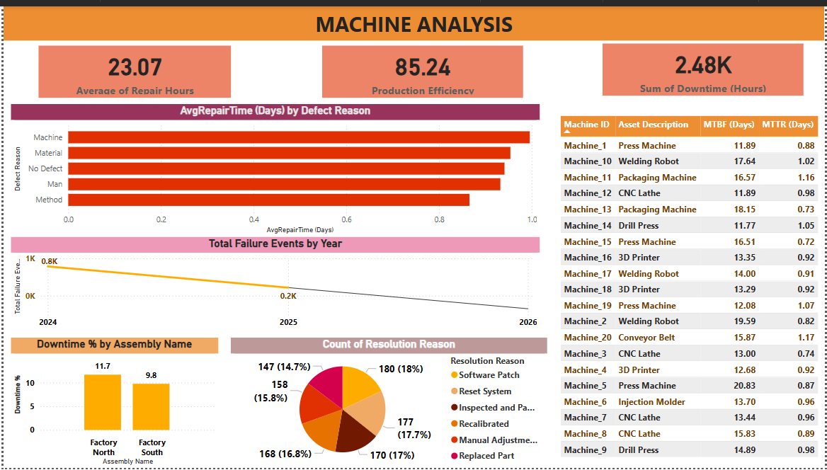

## **Machine Analysis Report: Purpose and Insights**

### **Why Do We Need This Report?**

This **Machine Analysis Report** provides a comprehensive overview of machine performance, downtime, and failure patterns in a manufacturing environment. It helps **maintenance teams, production managers, and decision-makers** to:  
 ✅ **Optimize machine performance** and minimize downtime.  
 ✅ **Identify recurring failure reasons** to improve preventive maintenance.  
 ✅ **Reduce repair time** and improve overall production efficiency.  
 ✅ **Track downtime trends** and identify critical assets needing attention.  
 ✅ **Improve resource planning** by monitoring machine reliability metrics.

## **Key Insights from the Report**

### **1️⃣ Key Performance Indicators (KPIs)**

🔹 **Average Repair Hours (23.07 hours)** → Measures the average time taken to repair machines.  
 🔹 **Production Efficiency (85.24%)** → Indicates how efficiently machines are operating.  
 🔹 **Total Downtime (2.48K hours)** → Summarizes total machine downtime due to failures.

💡 **Why It Matters:** These KPIs help measure overall equipment effectiveness (OEE) and guide maintenance teams in reducing repair time and increasing uptime.

### **2️⃣ Avg Repair Time by Defect Reason**

* **Machine failures have the highest repair time**, followed by material issues and human errors (Man & Method).  
   💡 **Why It Matters:** Helps identify whether issues are mechanical, material-related, or human-caused, allowing for targeted training, process improvement, or better maintenance planning.

### **3️⃣ Total Failure Events Over Time**

* Failure events are **decreasing from 800 in 2024 to 200 in 2025** (projected).  
   💡 **Why It Matters:** A positive trend indicating that **maintenance strategies and machine upgrades** are improving reliability over time.

### **4️⃣ Machine Reliability Metrics (MTBF & MTTR)**

* **Mean Time Between Failures (MTBF):** Measures how often a machine fails.
* **Mean Time to Repair (MTTR):** Measures how long it takes to fix a machine.

💡 **Why It Matters:**

* Machines with **lower MTBF need frequent maintenance** (e.g., **Drill Press, Press Machine**).
* Machines with **higher MTTR take longer to repair**, impacting production schedules (e.g., **Conveyor Belt, 3D Printer**).

### **5️⃣ Downtime by Assembly Name**

* **Factory North (11.7%)** has more downtime than Factory South (9.8%).  
   💡 **Why It Matters:**
* Helps **identify which facility needs more preventive maintenance or machine replacements**.

### **6️⃣ Count of Resolution Reasons**

* **Most common resolutions:**
  + **Replaced Part (18%)**
  + **Manual Adjustment (17%)**
  + **Inspected & Passed (17.7%)**

💡 **Why It Matters:**

* A **high number of replaced parts** indicates frequent wear and tear issues.
* **Manual adjustments and recalibrations** suggest that machines may require **better automation or fine-tuning**.

**Overall Benefits of This Report**

**Proactive Maintenance Planning** → Helps schedule maintenance before failures occur.  
 **Reduces Unplanned Downtime** → Identifies which machines are causing bottlenecks.  
 **Improves Cost Efficiency** → Reduces repair costs and extends machine lifespan.  
 **Enhances Production Output** → Ensures machines run efficiently, improving overall production rates.